**Supplementary Information**

**Table of content**

Model parameters of the DEB-IBM in control conditions 2

Review of the BPA effects 3

Energy from zooplankton and macroinvertebrates for each BPA condition 5

Simulation results based on dose-responses fitted on organism literature data. 6

Sobol’ sensitivity analysis 8

Made at the time corresponding to the end of the mesocosm experiment (211 days): 8

Comparison of the results at three different time of simulation (70, 140 and 211 days): 9

LOECs calculated with the mesocosm data or the DEB-IBM in control conditions 10

Populational dose-response curves 11

Comparison of the simulation with and without an effect on R for the founders 14

Dose-response curves for the BPA effects 15

References 16

# Model parameters of the DEB-IBM in control conditions

**Table S1.** Parameter descriptions and values of the DEB-IBM in control conditions (David et al. 2019)

|  |  |  |  |
| --- | --- | --- | --- |
| Parameter | Description | Value | Unit |
| DEB parameters | | | |
| $$δ_{M}$$ | Shape coefficient | 0.250 | - |
| $$E_{0}$$ | Initial reserve | 5.61 | J |
| $$E_{H}^{b}$$ | Cumulated energy invested in maturity at birth | 1.33 | J |
| $$E_{H}^{p}$$ | Cumulated energy invested in maturity at puberty | 375 | J |
| $${\{\dot{p}}_{Am}\}$$ | Maximum surface area specific assimilation rate | 2.42 | J/mm²/d |
| $$\dot{v}$$ | Energy conductance | 1.33 | mm/d |
| κ | Specific fraction of energy mobilized from energy from reserved allocated to growth and somatic maintenance | 0.757 | - |
| α | Fraction subtracted from κ to obtain κ in males after maturity | 0.111 | - |
| $$L_{egg}$$ | Size of primordial cell in physical length | 0.563 | mm |
| $${[\dot{p}}_{M}]$$ | Volume specific somatic maintenance costs | 0.119 | J/mm3/d |
| $$[E_{G}]$$ | Cost of synthesis of a unit of structure | 1.10 | J/mm3 |
| $${\dot{k}}_{J}$$ | Maturity maintenance rate | 0.003 | /d |
| $$k_{R}$$ | Reproduction efficiency | 0.978 | - |
| φ | Proportional factor to be fed ad libitum for a given day | 15.31 | J/mm² |
| $$T_{max}$$ | Water temperature above which consumption ceases | 25 | °C |
| $$Cq$$ | Rate at which the function increases over low temperatures | 3 | - |
| $$T_{opt}$$ | Optimal water temperature | 23 | °C |
| Reproduction parameters | | | |
| Photop.Thr | Minimum day time to start the reproduction | 11.305 | h |
| Breeding.Period | Time of the breeding period | 117.23 | d |
| Adult.Thr | Minimum length to determine fish sex | 26 | mm |
| L0 | Standard length of juveniles at hatching | 5.72 | mm |
| L_mat_founder | Standard mature length for the equations | 33.01 | mm |
| a_R.max | Calculation of the size clutch in function of the female length | 5.37 | 1/mm |
| b_R.max | Calculation of the size clutch in function of the female length | 16.8 | - |
| P.OL | Survival probability of eggs | 0.936 | - |
| A.clutch.max | Maximal duration of keeping eggs for a female | 2 | d |
| Proba.Stop | Probability of stopping the reproduction processes for a male | 0.09 | - |
| Part_Rmax | Fraction of eggs laid by a female | 0.703 | - |
| a_Nb.Egg | Maximum number of eggs in a nest in function of the male length | 58.8 | - |
| b_Nb.Egg | Maximum number of eggs in a nest in function of the male length | -437 | - |
| Time_harvest_mean | Harvest mean duration for males | 12.7 | % |
| Time.Acc | Time for male founder sticklebacks to acclimate themself to their new environment | -7 | degree/d |
| Female_Select | Maximal number of female to collect its eggs | 4 | - |
| Time_Dvpt_Eggs | Development time for the eggs | 6.9 | degree/d |
| R_min | Minimal energy for males to support the reproduction processes | 1586.56 | J |
| R_diff | Time between two reproductions | 11.14 | degree/d |
| A.territori.min | Minimal territory size for a male | 0.226 | m² |
| Gamma.Compete | Competition parameter for getting a territory | 0.15 | - |
| Food parameters | | | |
| a_food | Relationship Length - Mouth size | 0.297 | - |
| b_food | Relationship Length - Mouth size | -0.743 | mm |
| ratio_f | Ratio prey size/mouth size | 0.6 | - |
| K_dens | Parameter of density dependence for the food | 6692 | mg/m² |
| a_Kdens | Parameter of density dependence for the food | 0.437 | - |
| R_ref | Reference radius to calculate the radius of the water column | 57.60 | mm |
| L_ref | Reference length to calculate the radius of the water column | 23.54 | mm |
| Bold.M | Pourcentage of boldness for males during foraging | 0.17 | - |
| Survival parameters | | | |
| m_dens | Parameter for the density dependent mortality | 0.0000086 | - |
| mr | Malus for the survival of males in reproduction | 0.000856 | - |
| Mu | Natural mortality rate at unit weight | 0.00323 | 1/d |
| bN | Allometric scaling factor | - 0.0516 | 1/d |
| DP50_m | 50% of the density dependence | 4000 | mg/m² |
| M.nn | Daily mortality of the nests | 0.0191 | - |
| a_t | Parameter to calculate the mortality rate due to the temperature | 3.54 | - |
| b_t | Parameter to calculate the mortality rate due to the temperature | -90.8 | - |
| P.Dest.nid | Probability of destroying a nest after an attack | 0.01 | - |
| Variability parameters | | | |
| cv | Inter-individual variability | 0.061 | - |
| CV.c_M | Coefficient of variation of the mortality (inter-mesocosm variability) | 23.92 | % |
| CV.c_F | Coefficient of variation of the food (inter-mesocosm variability) | 14.94 | % |

# Review of the BPA effects

**Table S2.** Review of the BPA effects found in literature for fish.

|  |  |  |  |  |  |  |  |  |
| --- | --- | --- | --- | --- | --- | --- | --- | --- |
| **Species** | **Individual** | **Time of exposure** | **Nominal concentration** | **Measured concentrations** | **Condition** | **Type of effect** | **Effects** | **Ref** |
| **Stickleback** | Adult | 21 days | 2.5 µg/L to 280 µg/L | NO | in vitro test on kidney and in vivo test, contaminated water, flow through system | Reproduction | Inhibition of spiggin production | Jolly et al. 2009 |
| **Zebrafish** | Juvenile | 20 days | 1 and 10 μM | NO | Contaminated water, semi-static system | Reproduction | Sex-ratio disruption, inhibition of ovarian growth | Chen 2017 |
| **Zebrafish** | Juvenile | 45 days | 500, 1000, 2000 mg/kg | NO | fed with food containing BPA | Reproduction | Sex-ratio disruption | Drastichova 2005 |
| **Zebrafish** | Adult | 3 weeks | 5, 10, or 20 μ g/L | NO | Contaminated water | Reproduction | Maturity disruption in females | Santangeli et al., 2016 |
| **Zebrafish** | Adult | 96 hours | 0, 0.01, 0.1, 1.0, 10, or 100 µg/L | YES | drug delivered in a continuous flow | Reproduction | Induction of VTG | Villeneuve 2012 |
| **Zebrafish** | Adult | 14 days | 1, 10, 100 and 1000 μg/L | Yes in tissue | contaminated water, flow through system | Reproduction | Multiple alterations of the ovaries | Molina et al. 2013 |
| **Goldfish** | Adult | 28 days | 1, 10, 100 and 1000 μg/L | NO | Contaminated water, semi-static system | Reproduction | Induction of VTG | Ishibashi et al., 2001 |
| **Goldfish** | Adult | 90 days | 0.2 and 20 µg/L | NO | Contaminated water | Reproduction | Reduction of the steroidogenetic acute regulatory protein and increase of the estrogen receptors (ERs) mRNA transcript and mRNA transcript of androgen receptor in testis, brain- and testis-specific aromatase, and vitellogenin. Alteration of sperm. | Hatef et al. 2012 |
| **Cyprinus carpio** | Juvenile/Adult | 14 days | 1 to 1000 µg/L | YES | contaminated water, flow through system | Reproduction | Induction of VTG. Severe alterations of oocytes and testis structure (ex vivo test) | Mandich et al. 2007 |
| **Fathead minnows** | Adult | 96 hours | 0, 0.01, 0.1, 1.0, 10, or 100 µg/L | YES | drug delivered in a continuous flow | Reproduction | Induction of VTG | Villeneuve 2012 |
| **Salmo trutta** | Adult | 4 months | 1.75, 2.40, 5.00 µg/L | NO | contaminated water, flow through system | Reproduction | Impacts on sperms and ovaries | Lahnsteiner et al. 2005 |
| **Turbot** | Juvenile | 3 weeks | 59 µg/L | YES | contaminated water, flow through system | Reproduction | Altered sex steriod levels | Labadie and Budzinski, 2006 |
| **Guppies** | Adult | 21 days | 274-549 µg/L | / | contaminated water, flow through system | Reproduction | Significant declines in total sperm counts for males, no change in testis size and sperme lengths | Haubruge et al. 2000 |
| **P. promelas** | Adult | 164 days | 1 to 1280 µg/L | YES | contaminated water, flow through system | Reproduction | Induction of VTG. Inhibition of gonadal growth. Inhibition of spermatogenesis. Disruption of the egg production and hatchability. | Sohoni et al. 2001 |
| **Yellowfin seabream** | Adult | 7 and 14 days | 1, 10, 50, and 100 µg/g |  | Injected intraperitoneally per week | Reproduction | Elevated hepatosomatic index. Induction of VTG | Negintaji et al 2018 |
| **Japanese medaka** | Adult | 2 weeks | 0.3, 1, 3, 10 µg/L | NO | Contaminated water, semi-static system | Reproduction | Impacts on the number of eggs and hatchings. Only males were exposed. | Shioda and Wakabayashi, 2000 |
| **Catla catla** | Adult | 14 days | 10, 100, 1000 μg/L | NO | Contaminated water, semi-static system | Reproduction | Alterations of oocytes | Faheem et al., 2017 |
| **Goldfish, zebrafish, fathead minnow, and Nile tilapia** | Juvenile/Adult | 168 h | 100 µg/L, 300µg/L, 600µg/L, 800µg/L, and 1000µg/L | NO | Contaminated water, semi-static system | Reproduction | Induction of VTG | Allner et al 2016 |
| **Rainbow trout** | Adult | 3 h | 0, 30 and 100 µg.mL of BPA | NO | Trout oocytes were exposed for 3 h in ovarian fluid in ovarian fluid, followed by fertilization | Reproduction / Growth | Hatching delays, growth suppression and altered stress response | Aluru et al. 2010 |
| **Japanese medaka** | All stages | 60 days | 2.28, 13.0, 71.2, 355, and 1,820 µg/L | YES | contaminated water, flow through system | Reproduction / Growth | Inhibition of growth, decreased in both the total length and body weight. Disruption of the external secondary sex characteristics | Yokota et al. 2009 |
| **Japanese medaka** | Juvenile | 60 days | 1.5 mg/L | NO | Contaminated water, semi-static system | Reproduction / Lipid metabolism | lipid peroxidation in all the tested tissues, effects on GSI, activities of CAT in the liver, gill, testis, and ovary reduced, activities of GST in the liver and gill stimulated, Total number of eggs per brood was not significantly different between control and BPA/LD-BP treatments. Total number of brood reduced | Li et al. 2016 |
| **Gobiocypris rarus** | Adult | 7 days | 1, 15 and 225 µg/L | YES | Contaminated water, semi-static system | Reproduction / Lipid metabolism | Alteration of many genes involved in lipid metabolism, oxidative stress, and proteolysis processes. Effects on VTG, sex hormone and TG levels. | Zhang et al., 2016 |
| **P. promelas** | All stages | 444 days | 1 to 1280 µg/L | YES | Flow through system, solution delivered with peristaltic pumps | Reproduction / Survival | Induction of VTG Disruption of hatchability and eggs production. Effects on survival | Staples 2011 |
| **Fathead minnows** | Adult | 164 days | 1, 16, 64, 160, and 640 µg/L | YES | contaminated water, flow through system | Reproduction / Survival | Impact on male survival. Induction of VTG. Alteration of the male gonads. | Mihaich et al. 2013 |
| **Japanese medaka** | All stages | 7 days of embryonic development | 100 µg/L | YES | Contaminated water, water replaced daily until hatching | Reproduction / Survival | Transgenerational effects. Significant reduction in the fertilization rate in offspring and embryo survival. | Bhandari et al. 2015 |
| **P. promelas** |  | 96h | 1 to 13.3 mg/L |  | contaminated water, static test | Survival | Mortality test : LC50 = 4.7 (4 - 5.5) mg/L | Howard and Dill 1988 |
|  | 1 to 8.65 mg/L | contaminated water, flow through system | Survival | Mortality test : LC50 = 4.6 (3.6 - 5.4) mg/L |
| **Salmo salar** |  | 96 hours | 0.2, 1.5, 10.5, 100.5 and 1000.5 µg/L |  | Contaminated water | Accumulation | important accumulation rates and bioconcentration factors (BCF96) | Honkanen et al. 2004 |
| Egg/Larvae | 42 days | 10, 100 and 1000 µg/L | YES | Contaminated water, semi-static conditions (renewal after 48 h) | Development | Fluid accumulation (oedema) in the yolk sac and haemorrhages. Phlegmatic behaviour of the fry. Histological changes in liver cell nuclei. |
| **Zebrafish** | Adult | 5 days | 0, 10, 20, 40, 80, and 100 μM | Yes in tissue | static waterborne exposure | Development | Larval hyperactivity or learning deficits. | Saili et al. 2012 |
| 48 hours | 0.001, 0.01, 0.1, 1, or 10 μM |
| **Zebrafish** | Embryo | to 72 hpf | 10, 25, 50, 75 µM | NO | contaminated water | Development | Alteration of the early dorsoventral (DV) patterning, segmentation, and brain development | Tse et al. 2013 |
| **Coris Julis** | Adult | 14 days | 80 µg/ml | NO | Contaminated water, semi-static system | Development | Highly significant increased binding levels of subtype2 in hypothalamic areas, while markedly decreased levels of subtype5 were found in these diencephalic areas, as well as in the medial preglomerular nucleus. | Alo et al. 2005 |
| **Japanese medaka** | Embryo/Larvae | 9 days | 20 or 200 µg / L | NO | Contaminated water, semi-static system | Development | Embryonic deformities (pericardal edema, hemorragea, hemostasis) | Pastva et al. 2001 |
| **Gobiocypris Rarus** | Adult | 28 days | 15 μg/L | NO | Contaminated water, semi-static system | Lipid metabolism | Difference of the serum triglyceride contents. | Guan et al. 2016 |
| **Japanese medaka** | Adult | 60 days | 0.1, 1, 10, 100, or 1000 µg/L | NO | Contaminated water, semi-static system | Stress biomarker | Reduction of the activities of catalase (CAT), superoxide dismutase, glutathione peroxidase, glutathione S-transferase, and the content of reduced glutathione. | Minghong et al. 2011 |
| **Zebrafish** | Adult | until either 25 or 120 hpf | 0.1, 1, 10, 100, or 1000 µg/L | YES | Contaminated water | Reproduction | Disruption of the hatching time | Qiu et al 2018 |
| **Marine medaka** | Adult | 72 h | 76 µg/L | NO | Contaminated water? | Lipid metabolism | BPA significantly upregulated mRNA expression of lipid metabolism | Kim et al 2018 |
| **Rainbow trout** | All stages | 3 h | Eggs were enriched with 0, 4 and 40 ng of BPA | NO | Contamination via the ovarian fluid | Metabolism | Impacts on key genes involved in cortisol biosynthesis in the head kidney, as well as stress- and growth-related transcripts in the liver and muscle. | Thomas 2018 |
| **Zebrafish** | Embryo | from 0 hpf to 120 hpf. | 10, 100, 1000 µg/L | YES for 1000 µg/L | Contaminated water | Metabolism, Development | Alterations in the atrial:ventricular beat ratio and reduced heart rate. | Moreman 2018 |
| **Gobiocypris rarus** | Adult | 21 days | 15 μg/L and 225 μg/L | YES | Contaminated water | Reproduction | Poor quality of the embryos, increased malformation and delayed craniofacial cartilage ossification of the larvae. | Fan 2018 |
| **Zebrafish** | Adult | 2 weeks | 0.1, 1, 10, 100, or 1000 µg/L | YES in tissue | contaminated water, flow through system | Development | Dramatic decreases in the number of Cyp19b transcripts. | Molina et al. 2018 |
| **Cyprinodon variegatus** | All stages | until 111 dph. | 9.4, 19, 38, 75, 150, and 300 µg/L | YES | Contaminated water-intermittent-flow proportional diluter |  |  | Mihaich et al. 2018 |
| **Japanese medaka** | Embryo | 44 days post-fertilization | 6, 20, 60, 200 and 600 µg/L | Range 87.1 % to 104.4 % | Contaminated water, semi-static system | Reproduction | Transcription of VTG genes was induced in both sexes, indicating estrogenic disruption. Decrease of the hatchability. Increase of the growth of female larvae. | Sun et al. 2014 |
| **Zebrafish** | Adult, larvae |  | 0, 2, and 20 μg/L | YES | Contaminated water, semi-static system | Reproduction, neurotoxicity | Effects on reproduction and neurotoxicity. | Guo et al. 2018 |
| **O. niloticus** | Adult | 6 weeks | 1.64 and 3.28 µg/L | NO | Contaminated water, semi-static system | Growth | Fish growth and feed intake were significantly reduced. Total protein, albumin, globulin, and acetylcholine esterase decreased significantly; meanwhile, aspartate transferase, alanine transferase, alkaline phosphatase, uric acid, and creatinine increased significantly with exposure to BPA in a dose dependent manner | Abdel‐Tawwab et al. 2018 |
| **Zebrafish** | Adult | 7 weeks | 50 and 500 ng/L | NO | Contaminated water, semi-static system | Reproduction, Behavior | low dose BPA treatment decreased the male locomotion during courtship; and was associated with less courtship behaviours to female but more aggressive behaviours to mating competitor. | Li et al. 2017 |
| **Swordtail fish** |  | 96 h | 10, 13, 17, 22, and 29 ppm | NO | Contaminated water, semi-static system | Reproduction, growth | BPA caused vitellogenin mRNA expression. Following the long-term exposure, BPA exposures significantly affected the growth of swordtails. | Kwak at al. 2001 |
|  | 60 days | 0.2, 2, and 20 ppb |
| **Japanese Medaka** | Embryo/Larvae | 20 dpf | 200 ng/ml | NO | Contaminated water | Reproduction, Behavior | Following chronic BPA exposure, 20 dpf larvae showed suppression of locomotion, both in distance covered and speed of movement | Inagaki et al. 2016 |
| **medaka** | Embryo/Larvae | 60 days | 0.1, 1, 10, 100 and 1000 μg/L | YES | Contaminated water, semi-static system | Genetic | Negative impact on gene regulation | Qiu et al. 2016 |
| **Zebrafish** | Adult | 14 days | 1, 10, 100 and 1000 μg/L | NO | Contaminated water | Reproduction | Induction of VTG, significant increases in follicular atresia | Molina et al. 2018 |
| **Zebrafish** | Adult | 14 days | 1, 10, 100 and 1000 μg/L | NO | Contaminated water | Reproduction | deregulation of gonadotropic hormones causing degeneration of gonadotropic cells | Molina et al. 2018 |
| **Zebrafish** | Adult | 45 days | 10 µg/L | NO | Contaminated water, semi-static system | Metabolism | Bisphenol A toxicity in fish brain | Wu et al. 2016 |
| **Zebrafish** | Larvae | 72 -96 hpf | 0, 0.01, 0.1, 1, 10, 100 µg/L | NO | Contaminated water, semi-static system | Metabolism | Effects of BPA during normaxia and hypoxia | Cypher et al. 2018 |
| **Zebrafish** | Embryo | 48 hpf | 0.0068 μM | NO | Contaminated water | Metabolism | BPA increases neuronal birth (neurogenesis) within the hypothalamus, a highly conserved brain region involved in hyperactivity. | Kinch et al. 2015 |
| **Fathead minnows** | Egg/Juvenile | 26 days | 0.1, 1, 10, 100, 1000 µg/L | within x0.9 to x1.5 | Contaminated water, semi-static system | Growth | Effects on growth and development | Warner et al. 2017 |
| **Red Commun Carp** | Cell | 48 h | 0.1, 1, 10, 100, 1000, and 10 000 μg/L | NO | In vitro | Metabolism | BPA enhanced the antibacterial activity of macrophages and apotosis | Yang et al. 2015 |
| **Japanese medaka** | Embryo | 15 days | 200 µg/L | NO | Contaminated water, semi-static system | Development, growth | Decrease body length, deformaties, hatchling success | Zha and Wang, 2006 |
| **Zebrafish** | Adult | 6 months | 500 µg/L | NO | Contaminated water, semi-static system | Behavior | BPA exposure induced a significant decrease in group preference, as well as a weaker adaptability to new environment, | Wang et al. 2015 |
| **Zebrafish** | Embryo/Larvae | 96 h and 11 days | 0.10, 0.20, 0.30, 0.40, and 0.50mM | NO | Contaminated reconstituted medium | Metabolism | BPA caused chemical damage to developing cells by causing pericardial edema. | Fei 2010 |
| **Rare minnow** | Adult | 7 and 14 days | 15 μg/L | YES | Contaminated water, semi-static system | Reproduction | Results showed significant increase of gonad somatic index (GSI) and serum estradiol (E2) levels | Zhang et al., 2018 |
| **Rainbow trout** | all stages | 3 h | 3 and 30 ng/L | Yes in eggs | Ovarian fluid | Growth | Reduction of the growth during early development, followed by a catch-up growth post juveniles | Sadoul et aL., 2017 |

# Energy from zooplankton and macroinvertebrates for each BPA condition

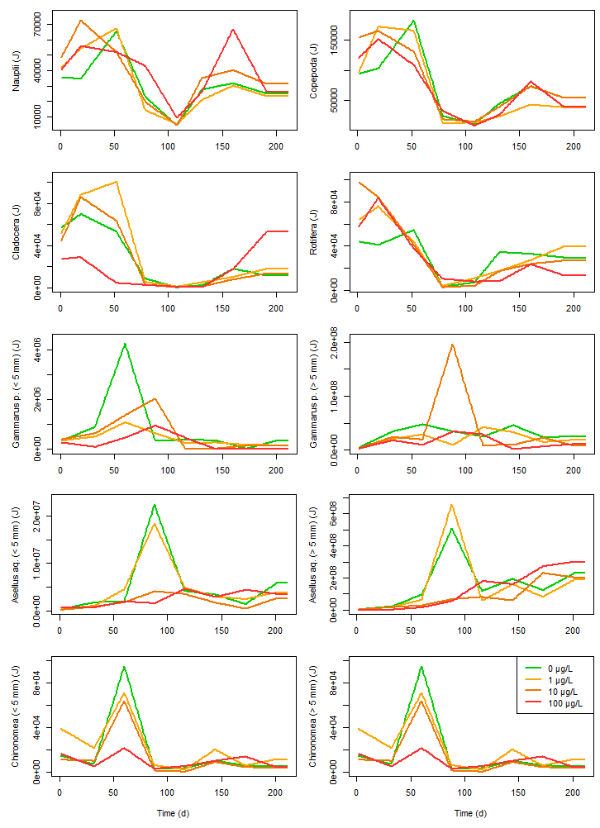

**Figure S1.** Energy from zooplankton and macroinvertebrates over time for each BPA condition (green: 0 µg/L, yellow: 1 µg/L, orange: 10 µg/L, red: 100 µg/L) used for developing the food scenario.

# Simulation results based on dose-responses fitted on organism literature data.

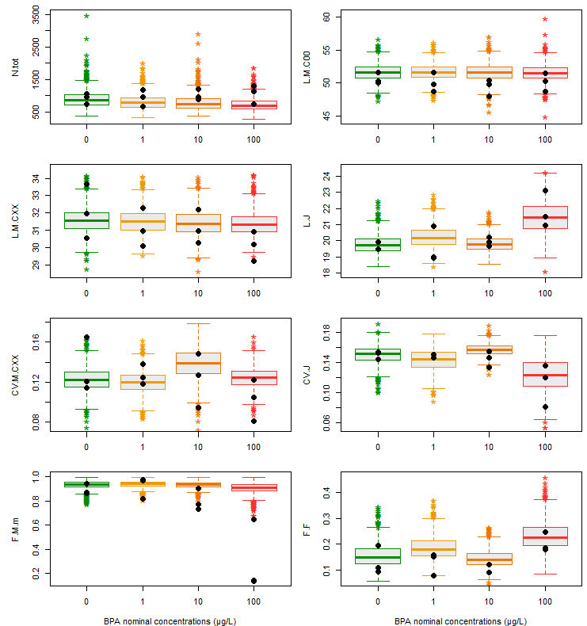

**Figure S2.** Simulation of the toxicity using the dose-responses developed with literature data for BPA impacts on physiological processes of sticklebacks. Boxplot represent the model predictions for each exposure condition (green: 0 µg/L, yellow: 1 µg/L, orange: 10 µg/L and red: 100 µg/L). Black points represent the observations made in mesocosms for each BPA condition.

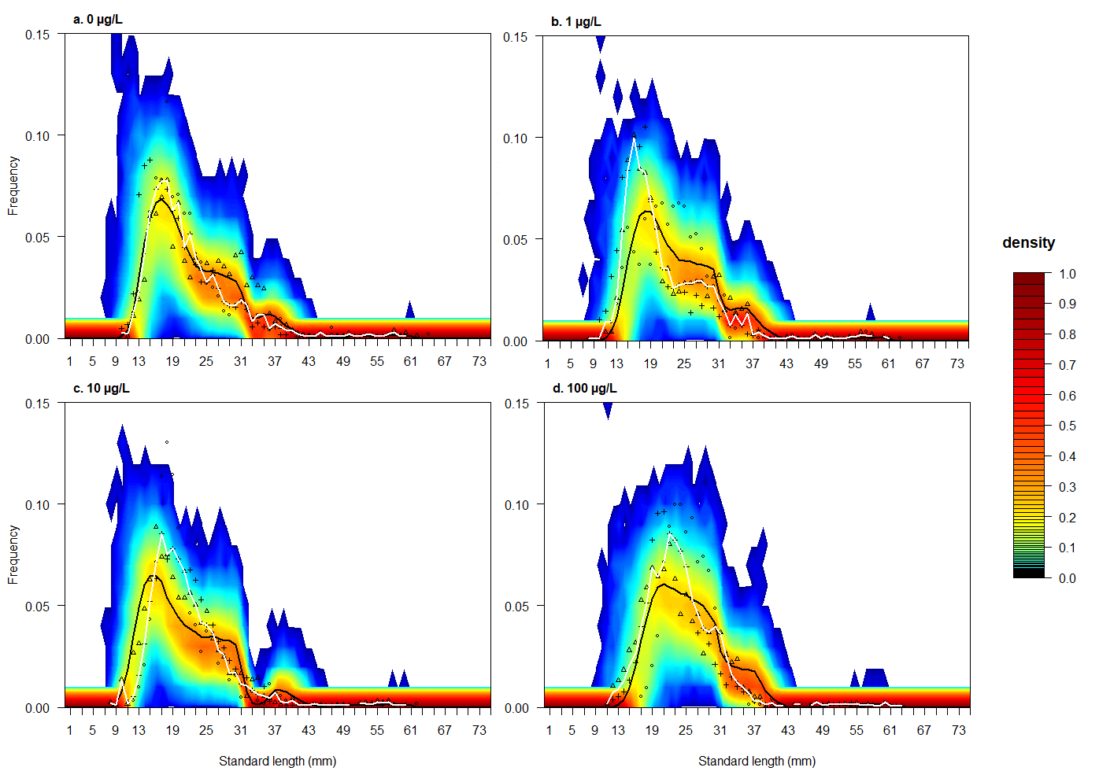

**Figure S3.** Probabilistic distributions of the length frequency predicted by the model length compared to frequency distributions observed for each toxic condition: 0 µg/L (a), 1 µg/L (b), 10 µg/L (c) or 100 µg/L (d) using the dose-response curves developed with organism literature data. Different point types represent the length frequency distributions of the different observed populations. Full black and white lines represent the median length frequency distributions of the simulated and observed populations respectively. Color level represents the frequency of simulated populations (n = 1000) having a given percentage of individuals for a given class length. Frequency inferior to < 1e-04 are represented in white.

# Sobol’ sensitivity analysis

## Made at the time corresponding to the end of the mesocosm experiment (211 days):

**Figure S4.** Results of the Sobol sensitivity analysis made at the simulation time corresponding to the end of the mesocosm experiment. The model outputs presented here are complementary with the ones presented in Figure 2 of the main text. The first order (light grey) and total index (dark grey) were represented on each graph. Error bars represent the confidence interval of each indice.

## Comparison of the results at three different time of simulation (70, 140 and 211 days):

**Figure S5.** Comparison of the Sobol sensitivity analysis results for made at three time of simulations which represented the beginning of the breeding period (70 days), the end of the breeding period (140 days) and the end of the mesocosm experiment (211 days). The first order (light grey) and total index (dark grey) were represented on each graph. Error bars represent the confidence interval of each indice.

# LOECs calculated with the mesocosm data or the DEB-IBM in control conditions

The LOECs were calculated using two different methods as presented in David et al. (2019). First, they were calculated using the observed data in the mesocosms along with a Dunnet’s post hoc test (method used in de Kermoysan et al. (2013)). Second, they were calculated comparing the distribution of the control endpoints estimated by the DEB-IBM to the observations made in the exposed mesocosms using a Kolmogorov–Smirnov test. The level of significance for the tests was 5 %.

|  |  |  |
| --- | --- | --- |
| Endpoints | LOECs using the observed control endpoints | LOECs using the simulated control endpoints |
| N.tot | > 100 | > 100 |
| N.F.C00 | > 100 | > 100 |
| N.M.C00 | > 100 | > 100 |
| **L.F.C00** | **> 100** | **100** |
| L.M.C00 | > 100 | > 100 |
| **L.F.CXX** | **> 100** | **10** |
| **L.M.CXX** | **> 100** | **100** |
| **L.J** | **100** | **100** |
| L.M.m | > 100 | > 100 |
| CV.F.C00 | > 100 | > 100 |
| CV.M.C00 | > 100 | > 100 |
| **CV.F.CXX** | **> 100** | **100** |
| CV.M.CXX | > 100 | > 100 |
| **CV.J** | **100** | **100** |
| CV.M.m | > 100 | > 100 |
| **F.M.m** | **100** | **10** |
| F.F | > 100 | > 100 |
| F.J | > 100 | > 100 |

**Table S3.** LOECs using the observed control endpoints in mesocosms or using the simulated control endpoints as references for the statistical tests.

# Populational dose-response curves

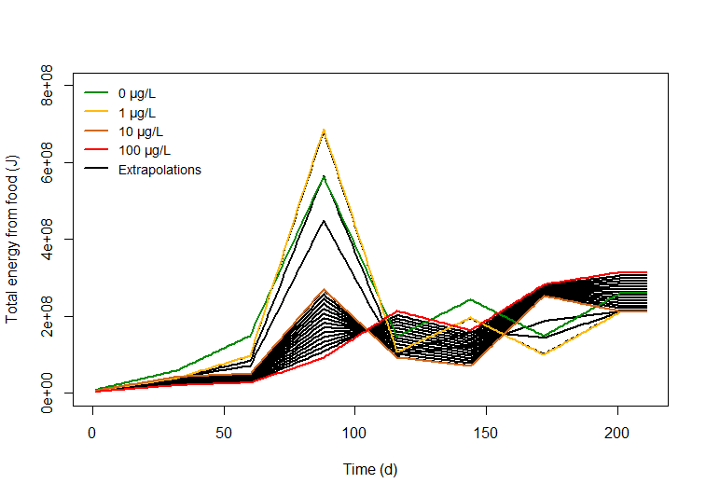

**Figure S6.** Food scenarios over time for each BPA treatment. The full lines in color represent the food scenarios which were calculated using the results of zooplankton and macroinvertebrate samples in the mesocosms (green: 0 µg/L, yellow: 1 µg/L, orange: 10 µg/L, red: 100 µg/L). The black full lines represent the extrapolated food scenarios for intermediate BPA concentrations (0.5, 1.5 and 2 µg/L and from 5 to 70 µg/L with a step of 5 µg/L).

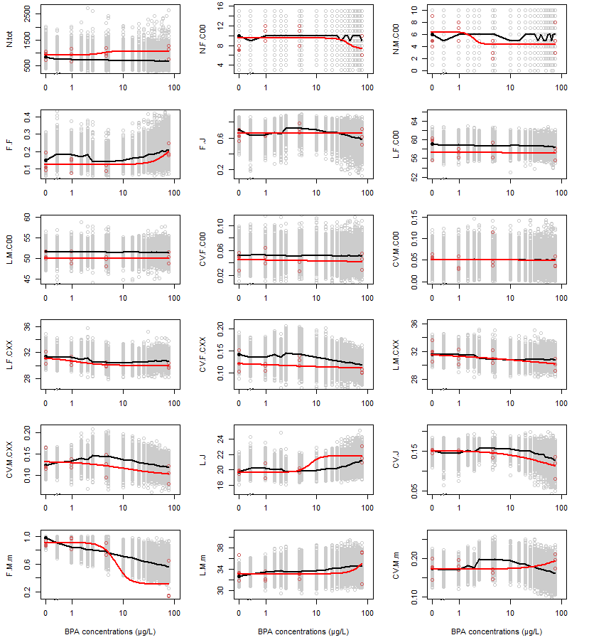**Figure S7.** Dose-response curves for each population level endpoint. The red points represent the real observations in the mesocosms for each BPA treatment and the red line the dose-response curve fitted on those observed data. The grey points represent the simulated endpoints with the DEB-IBM and the black line the extrapolated dose-response curves using the simulated data.

# Comparison of the simulation with and without an effect on R for the founders

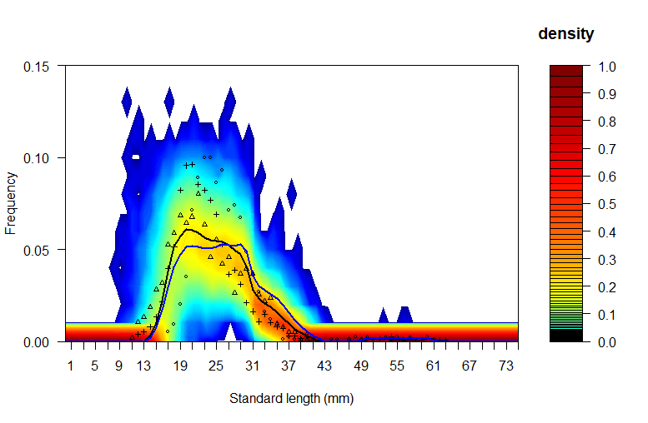

**Figure S8.** Comparison of the probabilistic distributions of the length frequency predicted by the model length compared to frequency distributions observed for each toxic condition for the 100 µg/L condition. Different point types represent the length frequency distributions of the different observed populations. Full black and blue lines represent the median length frequency distributions of the simulated populations with and without an impact on the gonads of founders respectively. Color level represents the frequency of simulated populations (n = 1000) having a given percentage of individuals for a given class length. Frequency inferior to < 1e-04 are represented in white.

**Table S4*.*** RE of the model predictions with and without a BPA impact on the gonads of founders

|  |  |  |
| --- | --- | --- |
| Impact on founder gonads | With | Without |
| RE | 20 % | 14 % |
| NRMSD | 0.26 | 0.22 |

# C:\Users\David\AppData\Local\Microsoft\Windows\INetCache\Content.Word\Fig S1.pngDose-response curves for the BPA effects

**Figure S9.** Dose-responses fitted on data from literature representing the BPA effects on the number of spawn eggs per female for F0 generations. Data are from three studies on fathead minnow.

# Script of the model

See additional files.

# References

David, V., Joachim, S., Tebby, C., Porcher, J.-M. and Beaudouin, R. (2019). Modelling population dynamics in mesocosms using an individual-based model coupled to a bioenergetics model. *Ecological Modelling*, 398, 55-66. doi: <https://doi.org/10.1016/j.ecolmodel.2019.02.008>.

de Kermoysan, G., Joachim, S., Baudoin, P., Lonjaret, M., Tebby, C., Lesaulnier, F., Lestremau, F., Chatellier, C., Akrour, Z., Pheron, E., Porcher, J. M., Pery, A. R. and Beaudouin, R. (2013). Effects of bisphenol A on different trophic levels in a lotic experimental ecosystem. *Aquatic toxicology*, 144-145, 186-198. doi: 10.1016/j.aquatox.2013.09.034.